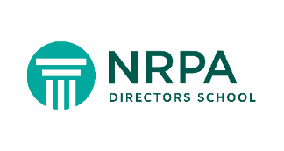

AMERICAN PARKS & RECREATION FOUNDATION

2023 John C. Potts Leadership Development Scholarship

The American Parks & Recreation Foundation (Foundation), philanthropic partner of the American Academy for Park & Recreation Administration is sponsoring scholarships to cover tuition only for two first-year students at the 2023 NRPA Directors School, which will be held August 13-17 in Oak Brook, IL. The two-year Directors School program is designed to prepare new and potential directors for the challenges of leading a parks and recreation agency.

Nominations are being accepted for the 2023 “Pottsie” Leadership Development Scholarships, which honors the Academy’s former Executive Director, John C. Potts. Your nomination must be supported by a current member of the Academy or by a Directors School Year 2 graduate. Eligible applicants must be a current member of NRPA.

The scholarship is intended to support assistant/deputy directors and mid-level managers who desire to be agency directors. Applicants should have demonstrated leadership potential within their organizations toward their goal of being an agency director.
Scholarship awards will prioritize candidates:
* from a minority population or underrepresented group in the parks and recreation profession * from a park agency that cannot pay a candidate’s tuition without a scholarship

John C. Potts Leadership Development Scholarship requirements and application:
NRPA Online Learning: 2023 Directors School Information

Required Materials to be submitted through the online application:
- Letter of nomination from a Directors School graduate or an Academy member
- Letter from your organization’s director (or your supervisor if you are a new director) that states why your parks agency is dependent on the scholarship to send you to the 2023 Directors School or a letter describing your status as a member of a minority population or a group that is underrepresented in the parks and recreation profession.
- Resume (not to exceed three pages)
- Essay describing how attending the NRPA Directors School will help you achieve your professional development goals to be an agency director (length not to exceed 500 words).
Completed applications must be received no later than March 31, 2023
2023 Directors School August 13-17, 2023 nrpa.org

